Table 4 Tweet Chats with Janet Thomas

Some practicalities of tweet chatting and a brief look at our research on the outcomes of participating in a tweetchat. For full information and help see www.physiotalk.co.uk

What is a tweetchat?
A tweetchat is an online discussion via Twitter usually hosted at a specific time and bound together using a single hashtag. For example, the Physiotalk tweetchat is held fortnightly on Monday nights at 8pm using the hashtag #physiotalk. The chats are usually promoted in advance with blog postings on the set topic to read ahead of the chat.

Why tweetchat?
It brings together people with a specific interest or shared profession (often from around the world) to a live, real time discussion on a set topic. As a participant in our research said: ‘It brings structure to an essentially structureless platform’.

How do you tweetchat?
Essentially by answering the questions posed by the chat host and making sure you include the hashtag in your reply as well.
On Twitter or a Twitter app you would search for the hashtag to see all the tweets sent using the chat hashtag. On Tweetdeck you set up a column to follow the chat hashtag. Tweetdeck means you can see tweets in real time and tweet from same web page as well as use multiple accounts.
You can also use services such as tweetchat.com, Hootsuite or twitterfall.com

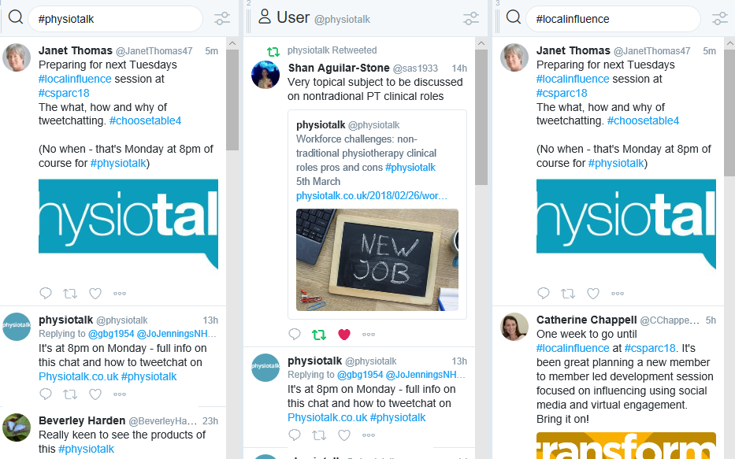

What do you get out of a tweetchat?
You mean apart from current awareness, influencing, networking, community, ideas generation, developing practice….?!

Our #physiotalk research developed a concept of both the connectedness and constructive change from tweet chatting (See WCPT abstracts for more info)
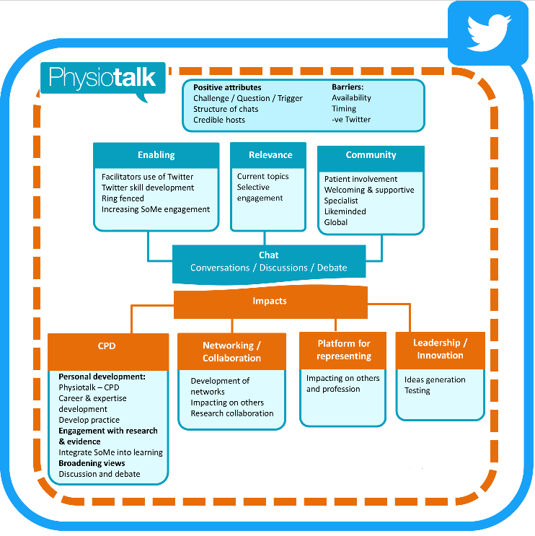

The impact of tweet chatting:
Depending on the questions asked you may
- Have gained consensus on a topic, for example @QMUPhysio used a tweet chat to generate ideas for curriculum redesign.
- Highlighted an issue to a wider audience which includes other HCP and service users
- Sparked participants ideas for ongoing CPD or introduced a new idea
- Made #globalPT connections – engaged and increased your community

After a tweetchat:
Usually a transcript is available – Physiotalk use Symplur but you can also collate tweets using a site like Wakelet for your own personal CPD

